# **1. SAB Narrative**

*Provide a Scientific Advisory Board (SAB)-generated narrative that addresses the following points:*

*Describe how the Management Plan has guided AViDD activities during the project period, whether it has changed, and how the plan will guide activities during the next project period.*

The ASAP Management Plan is operating as described in the Administrative Core Research Strategy, with the exception of replacing Ben Perry (who transitioned to join Medixi) with Peter Sjö (DNDi) as PI and Annette von Delft (MedChemica) as Project 6 Lead. Ben Perry has been added to the internal Scientific Advisory Board. New investigators brought into ASAP during the project period have been consolidated into Projects and Cores under their corresponding leadership.

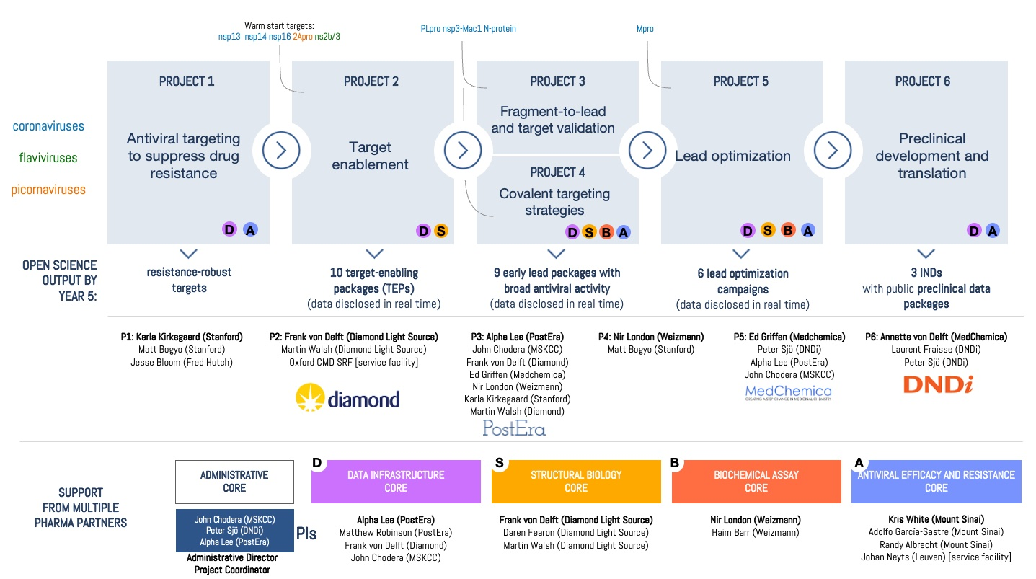

Administrative Core 1.4.2 Internal Center coordination: We currently hold weekly meetings with ASAP Investigators to ensure close coordination among Cores and Projects. The focus of these meetings rotates between (1) monthly all-hands meetings, (2) discussion of long-term strategy among Leads and other members, (3) science updates shared by Projects and Cores, and (4) a monthly Antiviral Drug Discovery Open Science Forum [<http://openantivirals.org>] that includes talks from and discussions with other AViDD Center investigators. In addition, cross-functional meetings between Project 1 (P1) and P2 are held weekly to coordinate target nomination and handoffs between these projects, while Program (target) focused meetings are held weekly for P5 lead optimization campaigns that include representatives of all relevant Cores.

During the next project period, the ASAP Management Plan will continue to operate as described in the Administrative Core Structure.

*Document interdependence between and among the Research Projects during the project period. Is there evidence of synergy among the Research Projects and Cores?*

As described in the Management Plan, ASAP is organized like a drug discovery biotech: Discovery Programs (focused on a Targeting Opportunity and breadth of viral family members) progress primarily sequentially from Project to Project (via the Administrative Core Research Strategy Section 1.5.2 Program Progression Process):

* The definition of Targeting Opportunities and nomination of Discovery Programs is a collaborative effort between P1 and P2 to select viable targets within our remit, with input from P5, P6, and the external Scientific Advisory Board in crafting appropriate draft Target Product Profiles (TPPs). The full SAB is then engaged to review and approve the Programs that have been initiated by P2, as well as deep mutational scanning (DMS) efforts in P1. This inter-project process has resulted in the definition of at least 22 potential Targeting Opportunities and the full detailed development of 7 targeting opportunities to date on the ASAP website, along with Target Product Profiles for all Programs that have entered P3.
* Target Enabling Packages (TEPs)---which provide X-ray fragment screens and validated assays—are produced by P2 based on these collaboratively defined Targeting Opportunities, and move into P3 and P4. The Biochemical Assay Core reformats these assays for high-throughput and the Structural Biology Core generates X-ray structures. At least 32 TEPs have been initiated, and 10 have completed X-ray fragment screens.
* Programs then progress to P3 (fragment-to-lead) and P4 (covalent targeting strategies) to generate lead compounds suitable for P5 (lead optimization). P5 assists in defining a Target Lead Candidate Profile that specifies criteria for leads acceptable into P5 Lead Optimization programs. All P3/P4 activity is supported by the Antiviral Efficacy and Resistance Core, the Biochemical Assay Core, and the Structural Biology Core. At least 5346 compounds have been synthesized and assayed by P3/P4 in this coordinated manner to date.
* Programs that progress into P5 (lead optimization) work closely with P6 to define a Target Candidate Profile (TCP) that specifies criteria for candidates acceptable into P6 (preclinical development). At least 882 compounds have been synthesized and assayed by P5 for the MERS-CoV/SARS-CoV-2 Mpro program. P5 and P4 have collaborated on chemical series with covalent warheads for this program. All P5 activity is supported by the Antiviral Efficacy and Resistance Core, the Biochemical Assay Core, and the Structural Biology Core. Public data disclosure is governed by the IP policy developed in collaboration between P6 and P5.

The Data Infrastructure Core and Administrative Cores support all Projects and Cores in the coordination, use, and sharing of data and coordination of activities, and collaborate closely in this work.

*Describe any weaknesses or deficiencies that have materialized and how they are being addressed.*

Deep mutational scanning:In Year 1, insufficient laboratory support for deep mutational scanning (DMS) activities across targets of interest to ASAP was rapidly identified as a deficiency by P1. This led to the integration into P1 of the Bolon/Flynn/Schiffer laboratories (UMass) to provide immediate DMS support for the SARS-CoV-2/MERS-CoV Mpro Program in P5; Evans/Richardson (Sinai) to support DMS activities for Zika polymerase, protease, and capsid; Lindebach (Yale) was awarded a Developmental Award to provide DMS (via eMAGE) for additional SARS-CoV-2 targets in Year 2. The Bloom lab also analyzed circulating SARS-CoV-2 variants to provide complementary data on mutational tolerance to inform resistance-robust inhibitor discovery. These activities have now generated a significant amount of deep mutational scanning data that are now integrated into all aspects of discovery via an interactive Fitness Viewer, with subsequent work on automated scoring for large-scale free docking and energy calculations underway.

Enzyme inhibition modeling support: A lack of enzyme assay modeling to support MERS-CoV Mpro biochemical assay estimation of affinity to the active dimer form was identified as a deficiency in supporting the SARS-CoV-2/MERS-CoV Mpro Program in P5, leading to a subaward to integrate modeler Minh (IIT) into the Biochemical Assay Core starting 1 May 2023. This has enabled us to more robust fitting procedures for estimating biochemical potencies, as well as the ability to determine Kd estimates for the MERS-CoV dimer, which correlate better with antiviral efficacy data.

Inter-AViDD coordination: A lack of central coordination between AViDD Centers was identified as an issue that risked significant duplication of effort between Centers. Together with the SGC component of the READDI-AC Center, we initiated the Antiviral Drug Discovery Open Science Forum [<http://openantivirals.org>] that provides a monthly forum for AViDD Center researchers to share updates and resources of use to other AViDD Centers. This forum has continued to provide highly useful avenues for inter-AViDD coordination and sharing of useful data and resources. We hosted 24 talks and 12 monthly Open Antiviral Drug Discovery Forum sessions over the reporting period, all of which are archived publicly online at the forum website.

IP policy: Progression of the COVID Moonshot predecessor project through the preclinical stage toward IND-equivalent filing and subsequent clinical development provided valuable insight into how ASAP’s IP strategy should be refined to balance the goals of global equitable access and open science. This insight was incorporated into a draft IP policy by P6 that guides our current operations: All data generated by P1-4 will be immediately disseminated, while some data from P5 will be delayed pending filing of single-compound patents held by organizations committed to licensing strategies that ensure global equitable access, with patents filed with the earliest possible publication dates. P6 data will be released upon IND-equivalent. This IP policy is in the process of being executed by all ASAP member organizations, and both a publicly-accessible explainer and a detailed preprint to enable others to follow the same strategy will be released shortly.

Triaging Discovery Programs: With early feedback from the external SAB who were concerned that running too many Discovery Programs simultaneously could detract from focus in both attention and resources, we have initiated a strict process to carefully review Discovery Programs entering and within P3. This has led us to pause or halt programs that were not maximizing our likelihood to succeed, as well as our ability to exploit ASAP’s unique platform capabilities. This process led to pausing/halting several programs in P3, including SARS-CoV-2 nsp3 Mac1 macrodomain and SARS-CoV-2 N protein.

Focus on Discovery Programs with greatest chance of successfully reaching key milestones due to abrupt end of funding: To attempt to address the abrupt change in funded duration—from the originally planned five years to three years—and enable programs to reach key milestones that will allow them to potentially continue progressing under funding sources other than AViDD or organizations other than ASAP, the SAB has been advising us on remaining nimble in pivoting to focus our effort on those programs with the highest chance of success as new data becomes available. Continual prioritization to maximize success is key.

*Describe how supplemental funds (if any) impacted overall AViDD activities.*

Not applicable